**Classroom Expectations**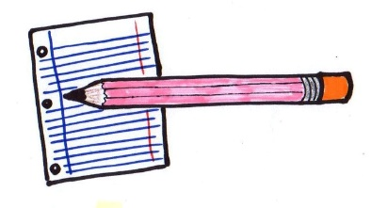

**1. You are expected to conduct yourself like you are in school. Please be sure to follow all rules and expectations that are asked of you.**

**2. You are expected to follow all school rules while you are on live video sessions.**

**3. All classwork and homework should be labeled with identifying information (name/date/class period) in the upper right hand corner of your paper.**

**4. All online assignments should be completed in black ink unless otherwise requested. Assignments that are physically submitted should be completed with a pencil.**

**5. All assignments are expected to be turned in on time. If extra time is needed, please inform me.**